Graphics and Visualization Project Report
Title:
Visual Exploration of Gene Expression Data: Insights Using Python and Power BI
Submitted by: Siddiqa rani
Submitted to: Sir Rizwan Shah
Date: 29/04/2025

Title:
Visual Exploration of Gene Expression Data: Insights Using Python and Power BI

1. Introduction
In today's world, analyzing gene expression data has become an essential tool in understanding diseases like cancer. In this project, I chose to work with breast cancer gene expression data to discover meaningful patterns using data visualization techniques. The goal was not only to plot the data but to make the hidden stories visible and understandable even for those without a deep technical background.
I used a combination of Python libraries and Power BI to create a smooth journey from raw numbers to clear visual insights.

2. Tools and Libraries Used
Throughout the project, I worked with the following tools:
- Pandas for managing and exploring the data.
- Matplotlib for creating basic but powerful plots.
- Seaborn for rich, beautiful statistical visualizations.
- Plotly for interactive and engaging charts.
- Scikit-learn for building a simple machine learning model.
- SHAP to explain the model's predictions in a human-understandable way.
- Power BI to design an interactive dashboard that tells the data's story at a glance.
Each tool helped uncover different aspects of the dataset and made it easier to draw logical conclusions.
3. Dataset Overview
The dataset I worked with comes from the Breast Cancer Wisconsin collection.
It includes detailed measurements of cell nuclei taken from fine needle aspirates of breast masses. It contains over 500 samples and 30 numerical features, such as mean radius, texture, perimeter, and area, along with a diagnosis label (Malignant or Benign).
Having both numerical and categorical data made it an ideal choice for meaningful visual exploration.
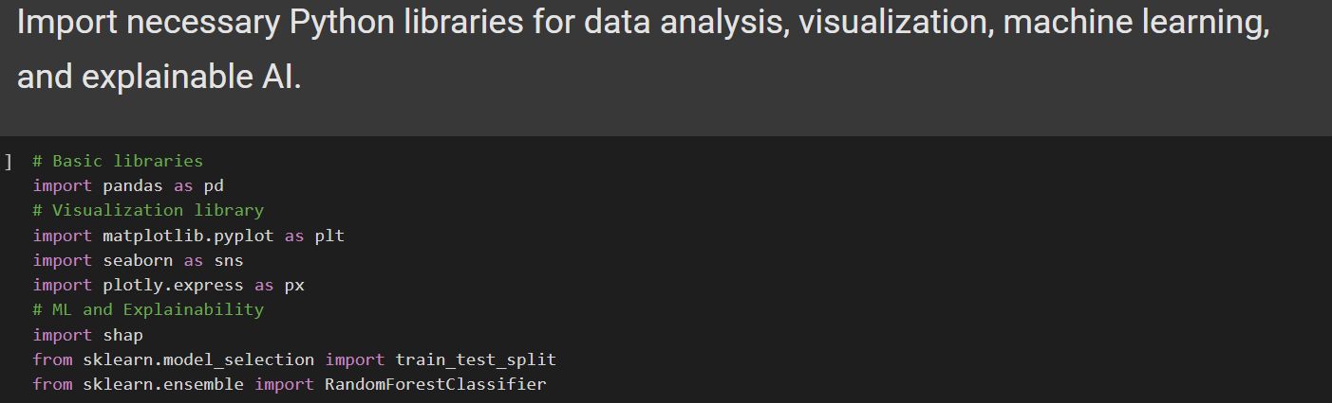
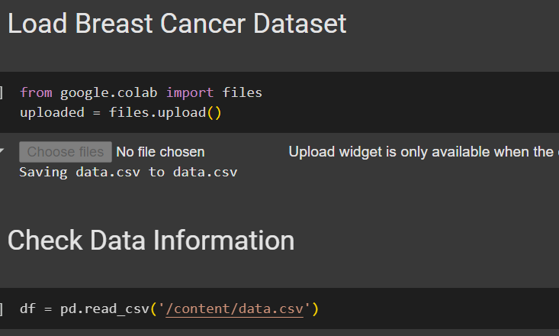

4. Visualizations and Insights:
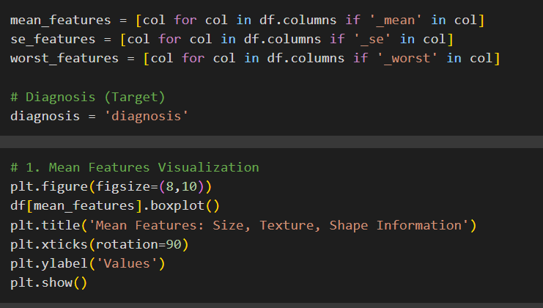
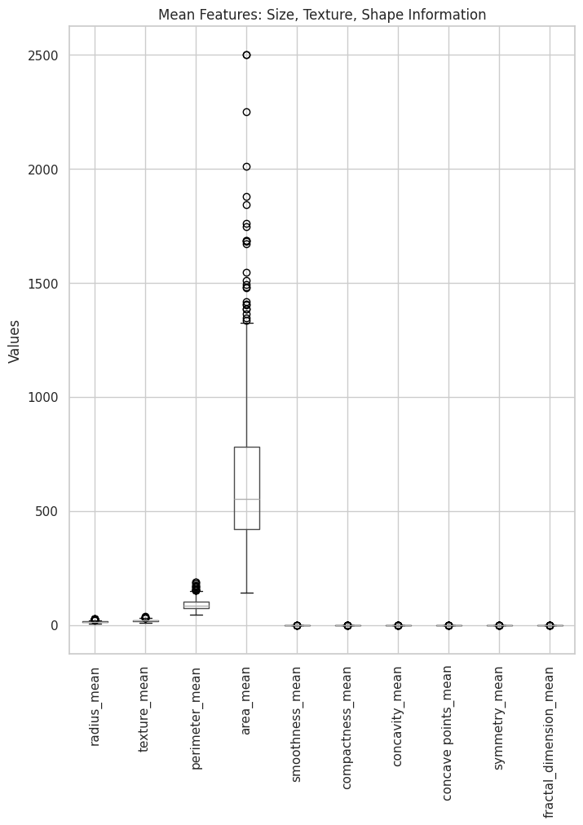

Diagnosis in upregulation :
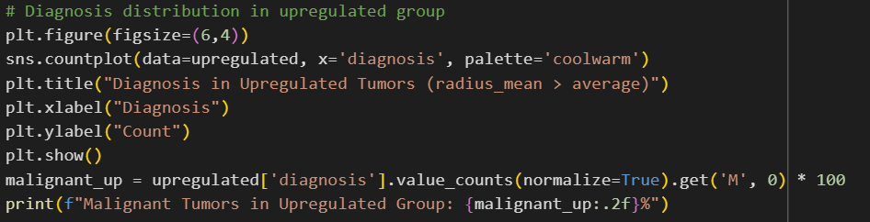
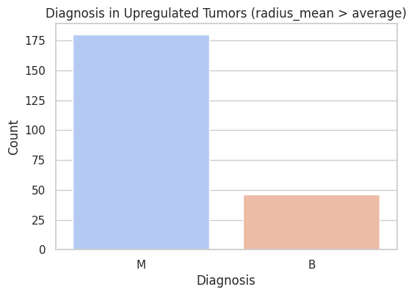

Downregulation:
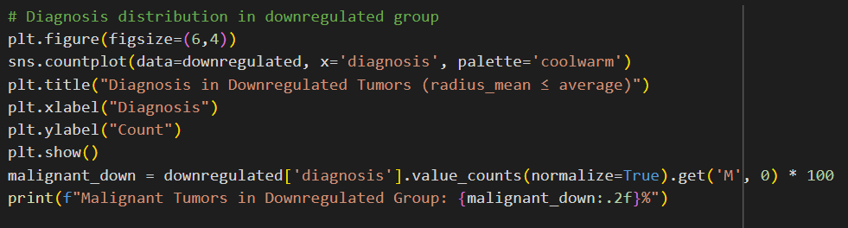
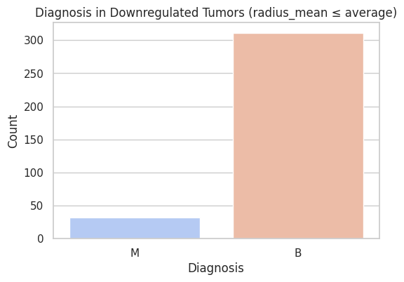

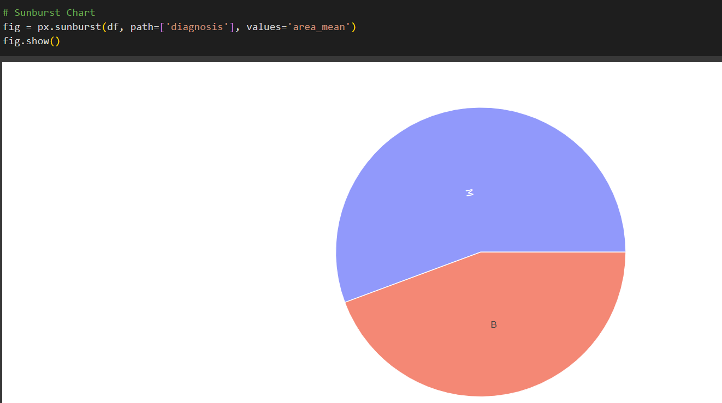

Bar Plot: Diagnosis Distribution (Matplotlib)
I started by plotting how many benign vs malignant cases were in the dataset.
It immediately became clear that the data is slightly imbalanced, benign tumors are more common.

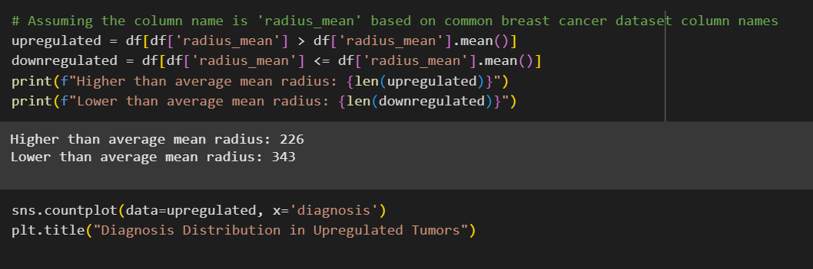

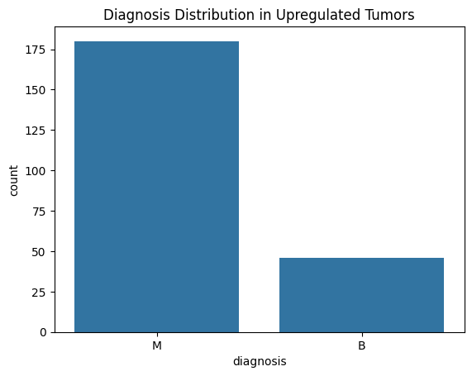

Line Plot: Mean Radius Across Samples (Matplotlib)
Plotting the mean radius for the first 50 samples showed sudden spikes.
These spikes likely represent tumors that have abnormal cell growth compared to the rest.

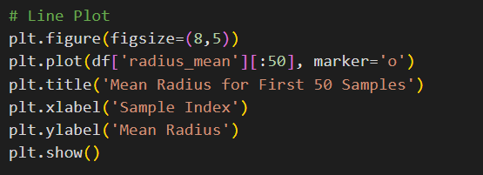
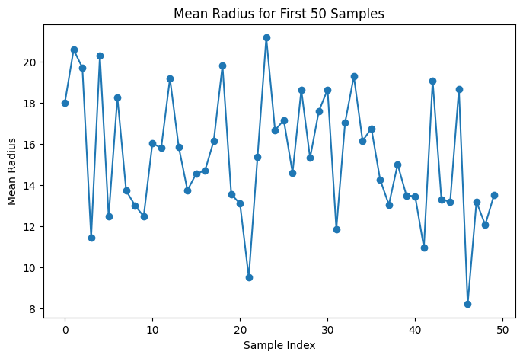

This line plot shows the mean radius (an indicator of tumor size) for the first 50 samples in the dataset. The values fluctuate significantly, ranging approximately from 9 to 22, demonstrating a high level of variability in tumor sizes even among a small group of patients. Some samples have very large radii, which may suggest potentially malignant tumors, while others are much smaller and may indicate benign cases. This visual helps highlight the natural diversity in tumor size among patients and emphasizes the importance of radius-related features in early diagnosis and further analysis.

Heatmap: Feature Correlations (Seaborn)
Next, I wanted to see how features are related.
The heatmap revealed that some features, like mean radius and mean perimeter, are strongly correlated.

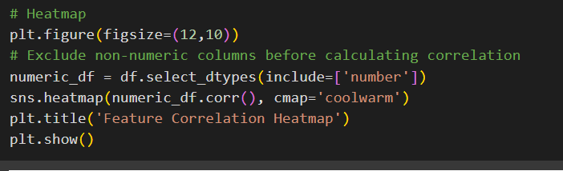

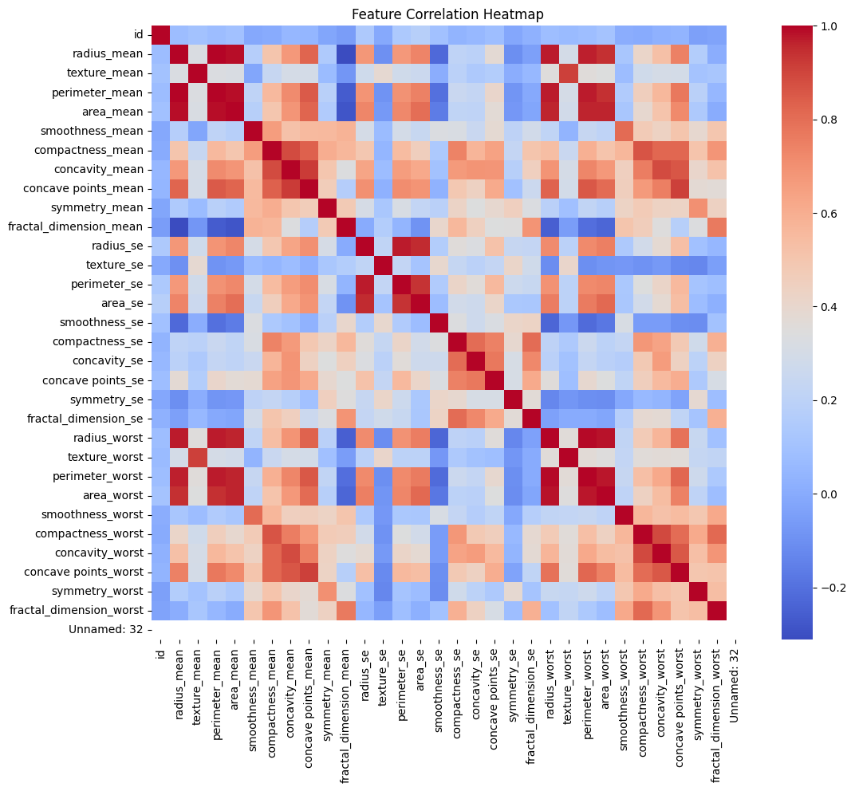

Pairplot: Feature Separation by Diagnosis (Seaborn)
The pairplot showed that malignant and benign tumors tend to form their own clusters based on certain features like mean radius and mean texture.
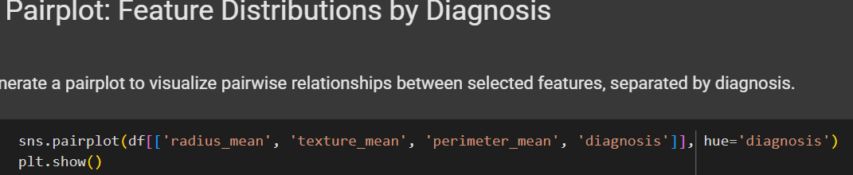

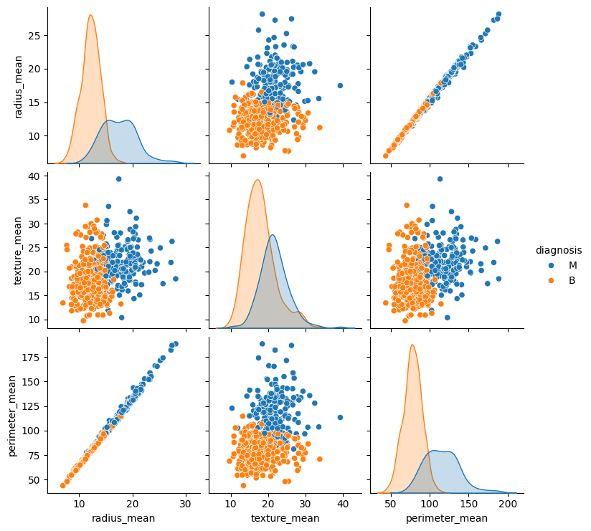

Interactive Scatter Plot: Mean Radius vs Texture (Plotly)
To make exploration more fun and dynamic, I used Plotly to create an interactive scatter plot. Hovering over each dot gives details about individual tumors, making data exploration easier for non-technical users.
Malignant tumors generally have higher mean radius and texture values.

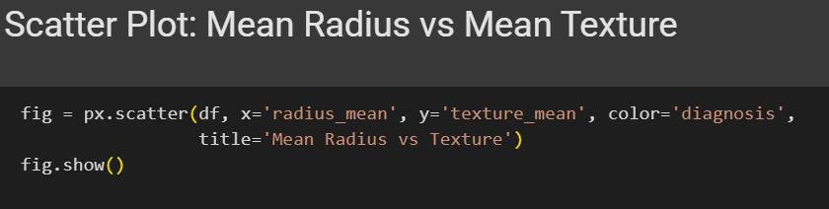

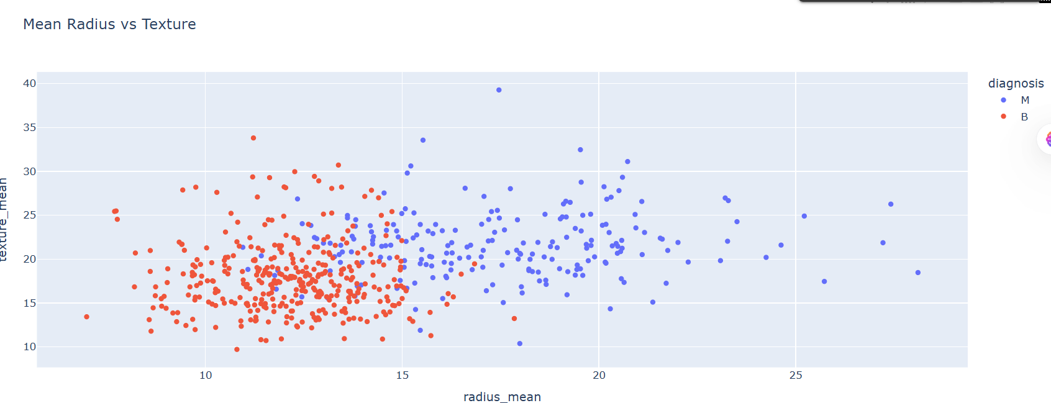

SHAP Summary Plot: Feature Importance (SHAP)
Finally, to explain the machine learning model’s thinking, I used SHAP.
The plot confirmed that features like mean perimeter, mean radius, and mean area were most influential in predicting whether a tumor was malignant.

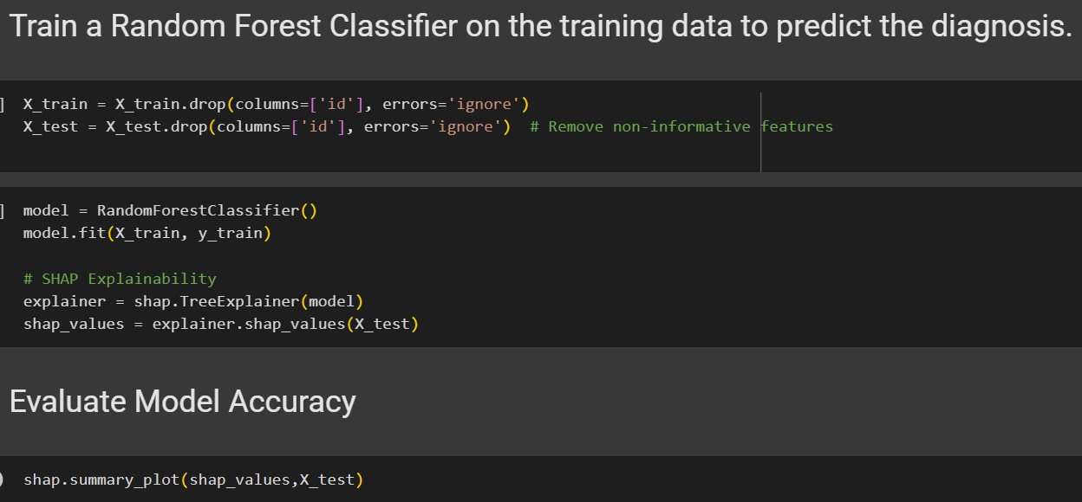

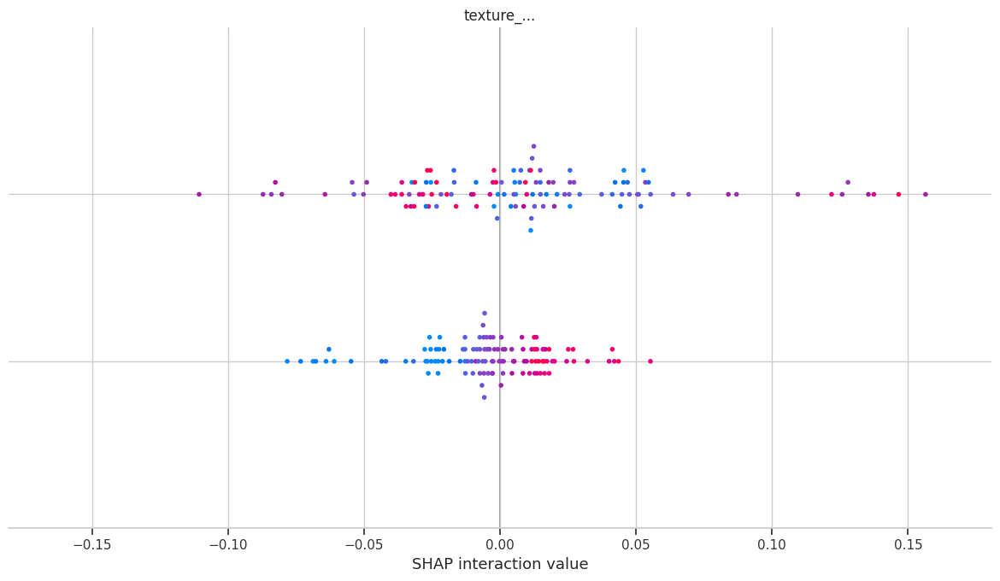

5. Challenges Faced
During the project, a few hurdles came up:
- Understanding feature redundancy using correlations took time.
- Balancing clarity and richness when designing visualizations was tricky — too much detail made some plots crowded.
- Using SHAP for the first time required learning a new approach to model explainability.
Overcoming these challenges helped me understand the real-world practicalities of data visualization and analysis.

6. Dashboard using Power bi:
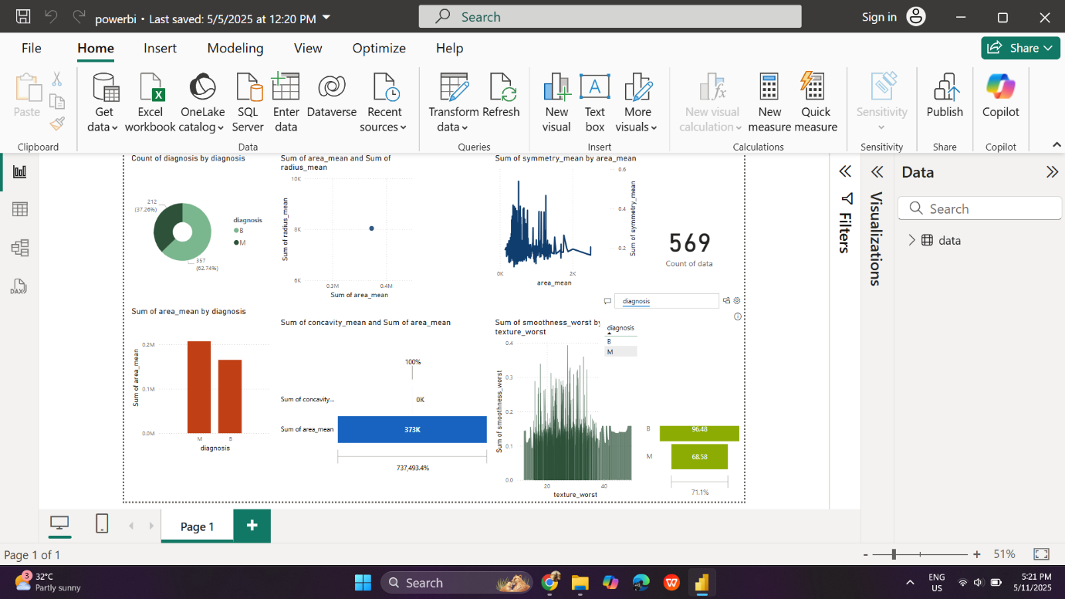

7. Conclusion
This project showed how powerful visual exploration can be when working with biological data.
By combining traditional charts, statistical plots, interactive tools, and model explainability, I could turn raw numbers into meaningful stories.
Moving forward, these skills can be extended to more complex datasets or clinical decision support systems, making science more transparent and accessible.
Data is powerful — but visualization is what gives it a voice.

